**Implementing the Singleton Pattern**

**Question 1: You need to ensure that a logging utility class in your application has only one instance throughout the application lifecycle to ensure consistent logging.**

**CODE:**

public class Logger {  
 private static Logger *log*;  
  
 private Logger() {  
 System.*out*.println("singelton is created");  
 }  
 public static Logger getInstance(){  
 if(*log*==null) *log*=new Logger();  
 return *log*;  
 }  
 public void log(String message){  
   
 System.*out*.println("[LOG]:"+message);  
 }  
}

public class Singleton {  
 public static void main(String[] args) {  
 Logger l1=Logger.*getInstance*();  
 Logger l2=Logger.*getInstance*();  
 l1.log("first log from Nantha");  
 l2.log("Second log from Sushil");  
 }  
}

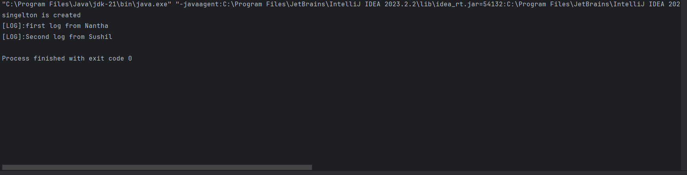

**Implementing the Factory Method Pattern**

**Question 2: You are developing a document management system that needs to create different types of documents (e.g., Word, PDF, Excel). Use the Factory Method Pattern to achieve this.**

**CODE:**

public interface Document {  
 public void generate();  
  
}  
class WordDocument implements Document {  
 @Override  
 public void generate() {  
 System.*out*.println("Word Document is creating..");  
 }  
}  
class PDFDocument implements Document{  
 @Override  
 public void generate() {  
 System.*out*.println("PDF Document is creating...");  
 }  
}  
class ExcelDocument implements Document{  
 @Override  
 public void generate() {  
 System.*out*.println("Excel Document is creating...");  
 }  
}

public abstract class DocumentFactory {  
 public abstract Document CreateDocument();  
}  
class WordDocumentFactory extends DocumentFactory{  
 public Document CreateDocument(){  
 return new WordDocument();  
 }  
}  
class PDFDocumentFactory extends DocumentFactory{  
 public Document CreateDocument(){  
 return new PDFDocument();  
 }  
}  
class ExcelDocumentFactory extends DocumentFactory{  
 public Document CreateDocument(){  
 return new ExcelDocument();  
 }  
}  
public class Main {  
 public static void main(String[] args) {  
 DocumentFactory WordFactory = new WordDocumentFactory();  
 DocumentFactory PDFFactory = new PDFDocumentFactory();  
 DocumentFactory ExcelFactory = new ExcelDocumentFactory();  
  
 Document wordDoc=WordFactory.CreateDocument();  
 Document PDFDoc=PDFFactory.CreateDocument();  
 Document ExcelDoc=ExcelFactory.CreateDocument();  
  
 wordDoc.generate();  
 PDFDoc.generate();  
 ExcelDoc.generate();  
 }  
}

